- TOWER OF HANOI
AIM
To write a Prolog program to implement the Tower of Hanoi problem using recursion.
OBJECTIVE
- To understand recursion in Prolog.
- To solve the Tower of Hanoi problem using three rods.
- To generate the sequence of moves required to transfer all disks.
- To follow the rule that a larger disk cannot be placed on a smaller disk.
ALGORITHM
- Start.
- Read the number of disks N.
- If N = 1, move the disk from source to destination.
- Otherwise, move N-1 disks from source to auxiliary rod.
- Move the largest disk from source to destination.
- Move the N-1 disks from auxiliary to destination.
- Repeat recursively until all disks are moved.
- Display all moves.
- Stop.
FLOWCHART:
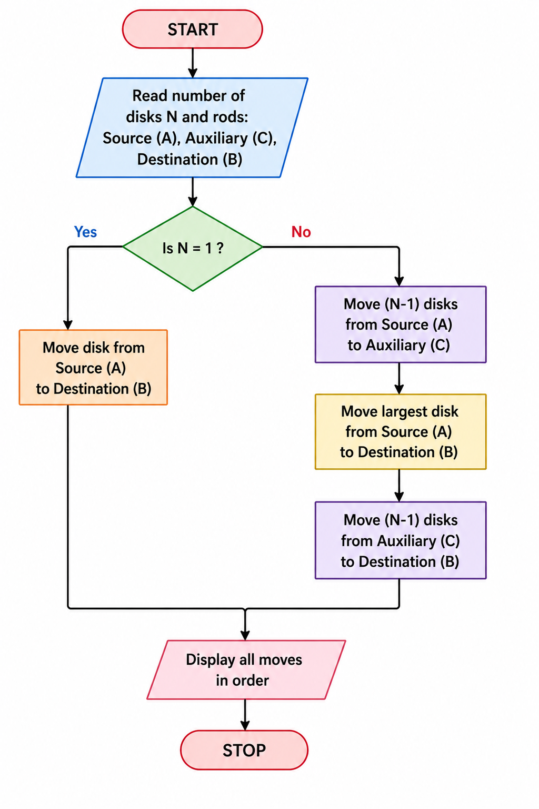
CODE:
hanoi(1, A, B, _) :-
write('Move disk from '), write(A),
write(' to '), write(B), nl.
hanoi(N, A, B, C) :-
N > 1,
N1 is N - 1,
hanoi(N1, A, C, B),
hanoi(1, A, B, C),
hanoi(N1, C, B, A).
OUTPUT:
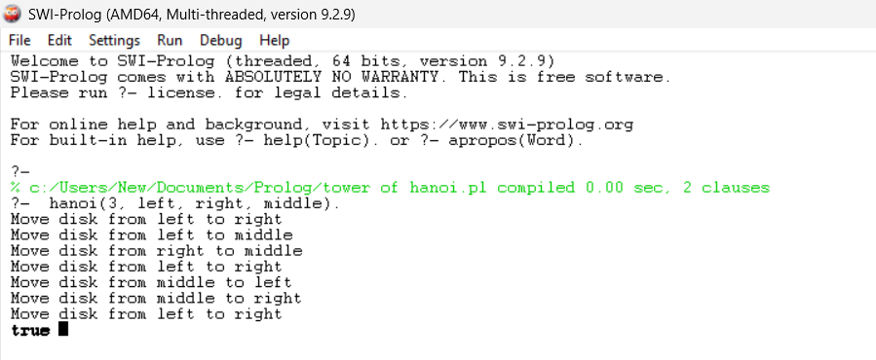
RESULT:
Thus, the Tower of Hanoi problem was successfully implemented in Prolog using recursion, and the sequence of moves required to transfer the disks was obtained.

